Hill-Climbing Fire Student Worksheet

Part 1: Program the fire to move according to the slope of the terrain.

Step 1: Change the Fire Move with Wind procedure to move according to only three cases depending on the slope ahead of a Fire agent.
- Locate the Move with Wind procedure in the Fire page.
- Remove the forward blocks from the Move with Wind procedure.
- (Leave the blocks for turning left and right, which cause the fire to spread with more wind.)

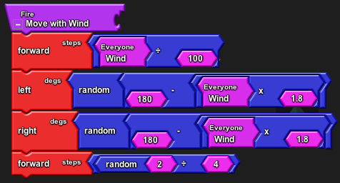

- If the fire is facing an even terrain (slope-ahead = 0), then move forward by half a step. Drag the ifelse block from the Logic drawer, slope ahead from the Terrain drawer, and = and numbers from the Math drawer.

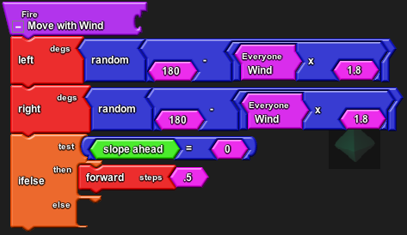

- If the slope ahead is not 0, then check if the slope ahead is positive (> 0). If the slope ahead is positive, move forward by a great amount. If the slope ahead is neither 0 nor greater than 0, it must be less than zero, or negative, so move by a lesser amount.

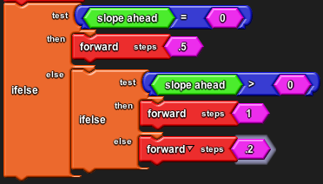

Step 2: Click Setup and Run to test this new Fire behavior. Use the terrain editor to create hills and valleys in Spaceland. Reference the How to Edit Terrain tutorial if you need to.

Step 3: (Optional) Set the x- and y-coordinates of the fire’s starting position.

First, click on the Edit Terrain button in Spaceland to bring up the grid so you can see the x- and y-coordinates for each patch. Write down (or remember) the coordinates where you want the fire to start.
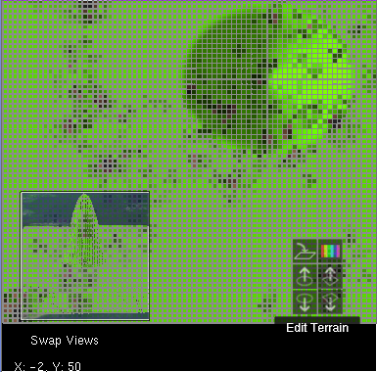

Second, go to the Start Fire procedure on the Fire Fighter page of the canvas, delete the current blocks in the xcor and ycor sections of the set xy block and replace them with your own coordinates for where you want the fire to start. Do this every time you want to change the starting place of the fire.
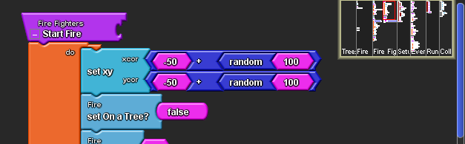

Simulation Questions: Answer the following questions below using your simulation and by editing your terrain. Back up your explanations with data from the simulation.

- Create one hill in the middle. Re-create the same forests you experimented with before using the same density and wind speeds. How does the fire spread in this terrain? Does the fire spread faster?

- Create an even bigger hill. Does the height of the hill effect how the fire spreads? Does it spread even faster?

- Create a valley in the middle. How does the fire spread in this terrain?

- Do lots of hills or one big hill effect fire spread more? Explain.

Part 2: Program some randomness in the movement of the Fire.

Step 1: Instead of having the Fire move at a fixed amount, use the random block to select numbers randomly. Make sure that the amount you move by still follows the rules we built in Part 1. (If slope > 0, move faster. If slope < 0, move slower.) Note that the block used is ÷ not +.

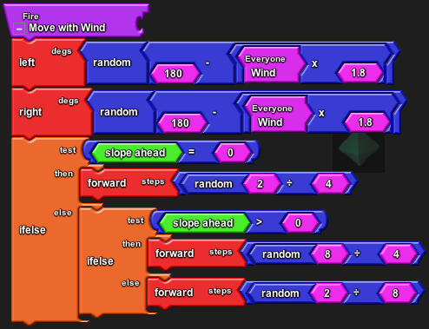

Step 2: Click Setup and Run in the Spaceland window and try out this new fire behavior under different terrains.

Simulation Questions:

- How does random movement affect the spread of the fire? What differences do you notice?

- Which simulation is more real? Fire moving at fixed steps or fire moving in random steps?

