Include at least one building!

Use the Breed Editor to make one of your types of agents be shaped like a building.

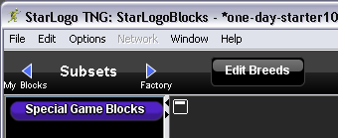

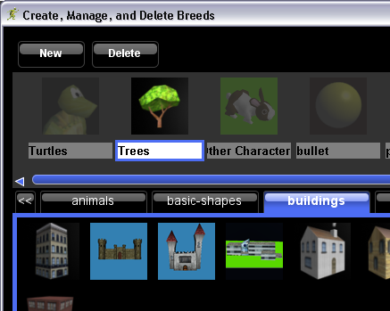
Hunt for a special item!

Treat one of your types of agents as a special item that gives you points when you collect it.

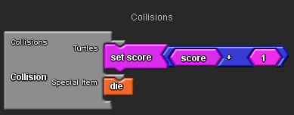
Include a game cheat!

Create special keys that give you special powers, extra health, points, etc. Or, create items or area of the terrain that give you special bonuses!

Example: you normally die when colliding with an enemy, but holding down “d” makes you invincible.

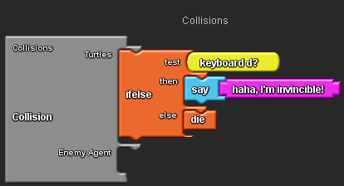
Moving obstacles!

Make one type of agent move around, and if you collide with it, make it deduct health or points.

Make your other type of agent move.

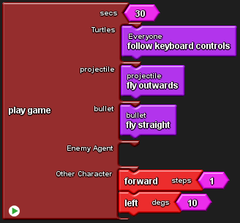

Example: if you collide with one, deduct 5 health points.

Race against the clock!

Example 1: when time is up, you must have 5 points or else you lose

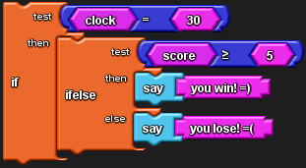

Example 2: increase your score by a little each time step, so the longer you live, the higher your score.


Involves flying!

Use the up and down commands to change your altitude, or height above ground.




Use the altitude block (with set altitude) to keep your altitude within good bounds.

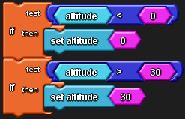
Involves swimming!

Use the up and down commands to change your altitude, or height above ground.

Use the altitude block (with set altitude) to keep your altitude within good bounds.

Change colors!

Set your color (or the colors of other agents) to specific values. Then, take actions based on those colors.



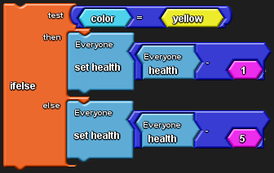

NOTE: remember to use model skin off if you want to be able to see what color agents are if they normally have more than one color.


Change size!

Set your size (or the sizes of other agents) to specific or changing values. Then, take actions based on those sizes.

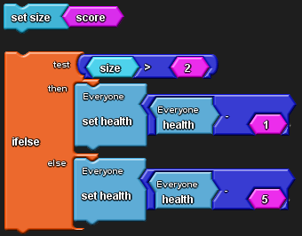

Make sounds!

Use play sound to make your agents make sounds. Can you make them play an interesting rhythm? How about controlling sounds based on keypresses?

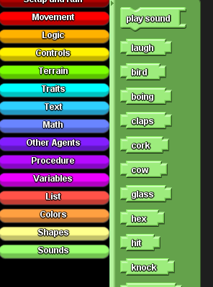
Change shapes!

You can change your shape (or any agent’s shape) while the game is running by using the set shape block with any of the shapes in the drawer.

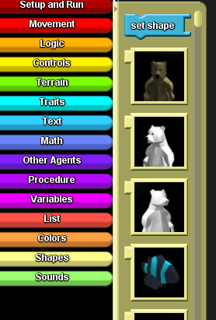
Collect something!

Make one of your breeds of agents be a treasure or other type of collectible item. Increase your score when you collect it, or think of other creative bonuses.

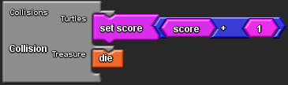
Follow someone!

Make your character follow another, or make someone else chase you! Use the face nearest special game block (described on the handout) to make an agent face its nearest neighbor of a given type.


Run away from someone!

You can run away from the nearest agent of a given type by first facing the nearest one, then turning around 180 degrees:

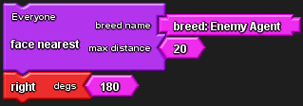
Say stuff!

You can make an agent say something (in a speech bubble over its head) with the say command.



Or, to say more complicated things, use the say stuff special game block that allows you to list a whole conversation at once.

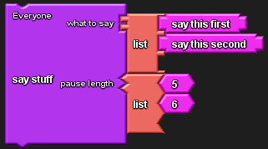
Death!

Can your character or others die? Use the die block to make a character disappear. If you are following that character, the screen will become darker.


Walls!

If you want to prevent an agent from walking over walls, make it check if there’s a wall ahead before moving forward.

Example:



