Modeling Change in TNG

Abstract: After doing a unit on constant velocity, it’s important for kids to realize that many things, other than position can change in a regular way…and that though two things are changing at the same time, those changes may be independent of one another. In this activity kids change 2 or more agent variables to create humorous combinations of change. They create simultaneous but independent change in their virtual worlds, thereby, establishing this important basis of a physicists understanding of motion in two dimensions.

Activity | Lesson Description | Materials | Learning Goals | TNG Programming Concepts/Blocks
Modeling Change | Use keyboard control to change at least two variable agent traits. | Modeling Change.sltng | Simultaneous and Independent Change Kids build programs where they can change two agent attributes independently and at the same time | Keyboard control  Booleans
  Key codepieces
  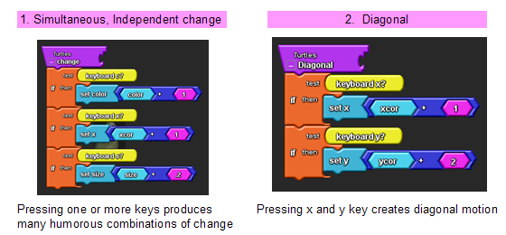

Activity: Teachers facilitate this activity – students build code
Have students open new TNG project and save it as Modeling change-their name.

Student Worksheet below.

Modeling Change

Introduction:In this activity you will change 2 or more agent variables to create humorous combinations of change. You will create simultaneous but independent change in your TNG worlds. This skill will be useful when building your own games and physics simulations.

I will facilitate this activity from my computer – you will build code at your computers.
Open new TNG project and save it as Modeling change-your name.
Watch screen, listen and ask questions as necessary.

Task #1: Go to Edit Breeds-→ select basic shape, letter or agent that appears white→name agent. OK
Setup, clear all, use ‘create and do’ block to create 1 of these agents.
Create and name a procedure to control an attribute of the agent using keyboard control
Example: Procedure name “Slide”
If keyboard x, set xcor [xcor + 1] Hang procedure call block on a master procedure block called “change” Hang change procedure call block on Forever block.
See below

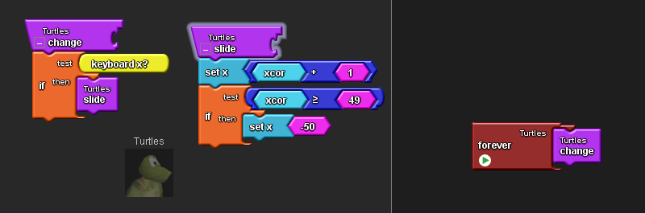

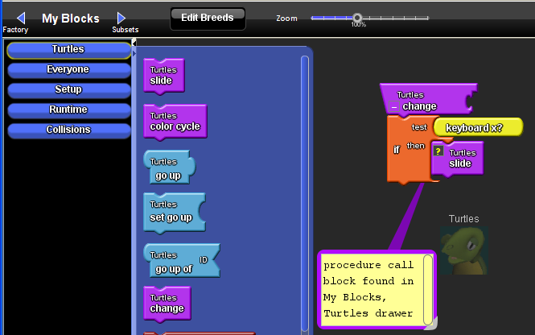

Test your procedure. Ask for help if you can’t figure out why your agent is not sliding across the screen

Some attributes you can change are
color; size; shape length, width ,height; altitude, xcor, ycor, heading
If you want the change to go up to a max value, then start at the beginning again, build code like this:
If xcor >49 , set xcor 1. See above. Or
If color > 139, set color 1.
If you want the variable to cycle up and down you must use a Boolean, a condition that is either true or false. In this case let’s create a condition called go up. Drag out an agent Boolean block from variables draw. Name it go-up. Set the initial value of the variable and the true or false of the Boolean in set up.
Reasoning goes like this:
If color > 135, set go-up false
If go-up false, set color [color -1]
If color < 1, set go-up true
If go-up true, set [color+1]

And looks like this:
See below
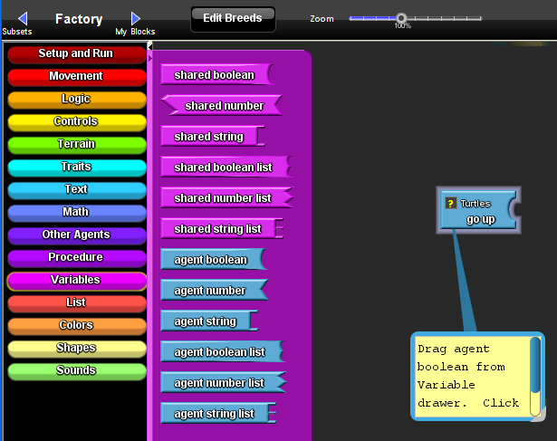

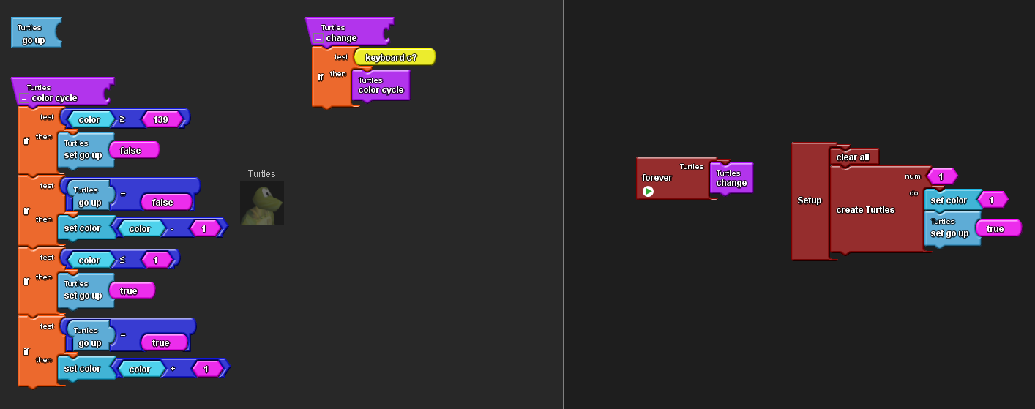

Test the program.

Task #2: Modify the program so that you can control two or more attributes at the same time using different keys.
For example:

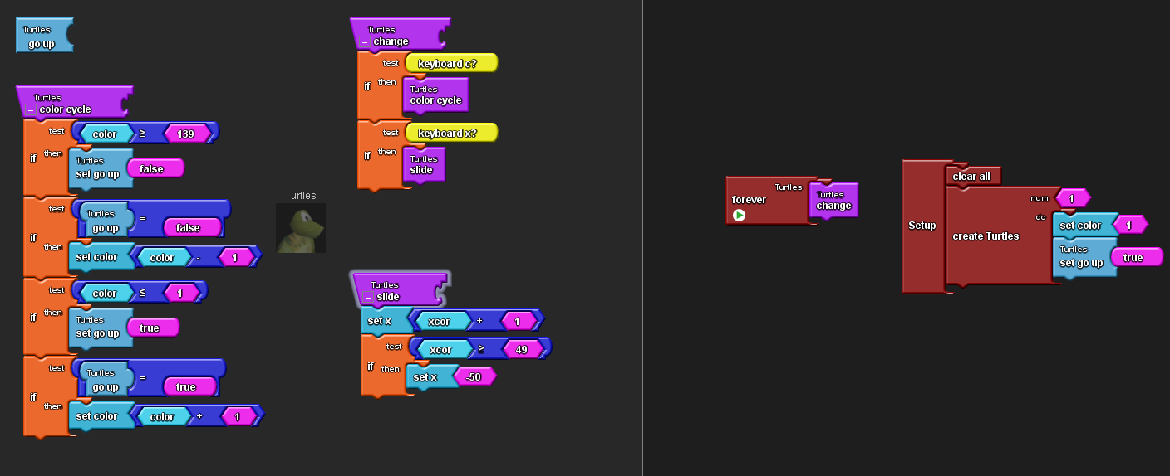

Questions:
1) What attributes did you modify?
2) How do you get two things to change at the same time?
3) Does changing one attribute affect the other in any way?
4) Do the changes depend on each other?

Task #3: Modify your program so that you can control xcor and ycor motion with separate keys. You can use the ‘stamp’ block to trace the path of your agent. Find stamp block in Terrain drawer.

Task #4: Run the program and change xcor and ycor at different times and at the same time.
Questions:
1) What type of motion do you get when you change x and y motion at the same time?
2) Does changing x change y?
3) Does changing y change x?

Task #5: Start your agent at the top left corner of the screen. Move the agent to the bottom right corner of the screen. Try multiple paths.
Question:
1) What path is the shortest? How could you use TNG to show that your answer is correct?

Debrief:
Have kids go around to each others’ computers to see what clever combinations of change they created. Ask kids how they created diagonal motion, emphasizing the fact that diagonal motion is created by simultaneously executing two independent commands. In the end you want to make sure everyone is absolutely clear with the fact that just because two things are changing at the same time, doesn’t mean that those changes have anything to do with each other.

