StarLogoTNG Biology Curriculum II: Teacher Guide

Overview

The StarLogoTNG Biology Curriculum II is a set of activities that deal with the relationship between genes and proteins. It describes the way in which the genetic code is used to determine protein shape, which in turn is used to determine protein function, which is regulated through protein networks, which ultimately result in a particular behavior within a cell. The projects portray processes as increasing scales within the cell with the aim of visualizing the connection between genotype and phenotype.

The curriculum is intended as a set of supplementary activities after the units on transcription and translation. It requires that students already know these basic mechanisms, and hence, it simplifies many of the visualizations. Teachers should try to set aside time at the end of each lesson to discuss the simplifications to review previously learned material and to reinforce the notion that scientific modeling is not an exact portrayal of real life.

The Biology Curriculum II is the second installment of StarLogoTNG biology projects, and it assumes that students are comfortable with the StarLogoTNG software. Though the units are light on programming, it is still advised that you spend some time on introductory activites, should you choose to skip Biology Curriculum I.

Unit Summaries

Lesson 1 takes place in the cytoplasm of the cell, where we see what happens to the chain of amino acids after transcription and translation are completed. Students will observe how a protein folds, given a simple set of attractive and repulsive forces. Then they will mutate the DNA to see how mutations can affect the protein folding. Finally, they will observe the affect that temperature has on the system.

Lesson 2 takes place in the nucleus and cytoplasm of the cell, where we see how proteins with different shape take on different functions. This cell produces a “Mario enzyme” that gets rid of “weeds” in the cell. Students will then mutate the DNA to see how certain mutations have no effect on the protein shape, while others have a profound effect. A mild mutation of Mario is Luigi, and a severe mutation of Mario is Wario. However, because there are two strands of DNA present in the cell, students will see how two copies of a gene affects the overall phenotype of the cell.

Lesson 3 takes place in the nucleus, cytoplasm, and extracellular space of the cell, where we see the way in which multiple proteins interact in a network. The cell produces a “Homer enzyme” that eats donuts that appear outside of the cell. However, Homer is only produced in the presence of donuts, so a “Marge membrane receptor” sends a messenger protein to turn on transcription whenever she encounters a donut outside the cell. Key points in this lesson include understanding how cells communicate, and investigating the role that feedback plays in maintaining function within a cell.

Lesson 4 takes place in the cell and lumen, where we observe mutations within tissues. Students will “grow” the tissue from a given stem cell and mutate it at various stages in the process. The first part deals with a mutation in the enzyme gene and the difference between an inherited mutation that propagates to the whole tissue and an accumulated mutation that affects only one cell in the tissue. The second part deals with a mutation in the cell cycle, which (if given the opportunity) may eventually lead to tumor growth. Students will test the effects of various cell cycle mutations, then use a first-person “tumor eater” to treat the tumor using chemotherapy, excision, and targeted particle heat blasting. Finally, students use what they learn to change the difficulty of the game.

About the Guide
Each lesson includes the following:
- Goals: The overarching theme of the activity.
- Biology Concepts: Concepts in the biology curriculum that are covered.
- Materials: Materials needed for the activity.
- About the Model: Technical information about the model and code. This description is very detailed and for reference only.
- Possible Modifications: Changes that can be easily made to the model to support different goals (of course there are many other possible modifications of varying difficulty to implement).
- Suggested Teacher Guide: Outline of a suggested lesson.
- Student Worksheet (printout): Student worksheets for distribution.
Project files include the following:
- project.sltng: Starter code for students to do the activity.
- project-sol.sltng: Solutions code for teacher reference. Contains all completed code in programming portions, as well as detailed commenting of all procedures.
LESSON 1: PROTEIN FOLDING

Goals:
The goal of this lesson is to examine the open problem of Protein Folding. Through the activity, students should understand the basic mechanisms by which proteins fold, the reasons why protein folding is an important field of science, and the barriers preventing the problem from being solved. In addition, students should see that random processes and decentralized behavior occur even on a microscopic level, and not just on the organismal level seen in the ecology units. This first project also introduces students to the StarLogoTNG cell setup, which will present a visual frame of reference as the scale of each project increases from proteins to cells to tissues to organisms to populations.

Biology Concepts:
- Protein sequence dictates protein shape
- The Protein Folding Problem
- Chemical energy and chemical bonds
- Protein denaturization
- Types of mutations

Materials:
- A large physical space
- Colored paper and tape
- Camera (optional)
- Starter code: 1-ProteinFolding.sltng
- Blackboard/whiteboard/large paper for brainstorming

About the Model:
For more about the Basic Cell Setup, see Appendix A.
For more about “birth” procedure variables, see Appendix B.
For more about attachments and chains, see Appendix C.
The scale of this project focuses on the cell cytoplasm.

SETUP:
“Setup Variables” clears the board, then initializes the variables and the hidden terrain agent. The terrain agent sets the “DNA sequence” as a list of 30 random DNA base colors, then hatches all of the necessary cell components when the “Setup Cell” button is clicked. The cell is initialized with one strand of DNA, one RNA polymerase, and one free ribosome. Individual agents set up their own agent variables using “birth” procedures. In particular, the DNA uses the “DNA sequence” to create a chain of base pairs matching the sequence.

FOREVER:
Polymerase procedures:
- When “Transcribe” is clicked, the polymerase is attached to the DNA promoter (“attached id” set to the white colored base pair). It follows along the strand and transcribes a strand of RNA.
RNA procedures:
- The RNA moves as a chain towards the ribosome.
Ribosome procedures:
- Upon collision with the RNA, the ribosome sets its “attached id” to be the id of the first RNA base pair and uses it to follow along the strand. After each RNA base pair is read, it dies.
- The ribosome reads three base pairs at a time and registers them as a “codon.” After each codon is read, the ribosome hatches an amino acid of the given color.
- The first two base pairs of each codon are used to determine the amino acid color (meaning that any mutation in the third base pair would be considered silent). The ribosome averages the DNA complements of the first two base pairs and subtracts 4 to get the final amino acid color (subtracting four just adjusts the color so that it is not so dark.) The colors that result are:
  - red + green = (15+55)/2-4 = 31 (brown)
  - red + blue = (15+105)/2-4 = 56 (light green)
  - red + yellow = (15+45)/2-4 = 26 (orange)
  - green + blue = (55+105)/2-4 = 76 (turquoise)
  - green + yellow = (55+45)/2-4 = 46 (yellow)
  - blue + yellow (105+45)/2-4 = 71 (emerald)
Protein procedures:
- The algorithm for protein folding is fairly simple. It is based on the similarity in amino acid colors. Colors that are < 20 apart are considered “repulsive” and colors that are > 25 apart are considered “attractive.”
  - Make a list of all attractive amino acids and a list of all repulsive amino acids within a radius of 50.
  - Choose the first (aka the closest) off the attractive list and move to a distance of 2 from it.
  - Choose the first (aka the closest) off the repulsive list and move a distance of 1 away from it.
  - Move to a distance of 2 from prev neighbor (to maintain the covalent bonds in the chain).

TEMPERATURE:
The slider “temperature” has the following effect on the protein movement, slowing down its movement at temperatures < 20 and increasing its movement (and also unfolding) at temperatures > 70:
- Temperatures above 70 will cause attractive forces to get weaker by:
1x (1-(temperature-70)/30)
- Temperatures above 70 will cause the first amino acid (with prev neighbor = -1) to move forward by:
1x (temperature-70)/30
- Temperatures below 20 will cause the repulsive forces to get weaker by:
1x (temperature/20)

TRANSCRIBE:
The polymerase sets its “attached id” to be the promoter id so that it will transcribe when “Forever” is run.

PERTURB:
The “Perturb” button just moves the protein back to the center and disturbs it a little. It’s meant for the occasions when the protein gets stuck in the corners of the board.

RESET DNA COLORS:
When the DNA colors are “mutated” in the latter part of the activity, they can be reset to the default by clicking “Reset DNA Colors.” To do this, the individual DNA base pairs check their current color against the color that is listed at the same index in the “DNA sequence” variable.

Possible Modifications:
To change how the protein folds just modify the procedure “Move (Amino Acid)” under the amino acid breed. Each amino acid has knowledge about its “prev neighbor” and “next neighbor” and its “color,” which is all that you should need.

Be sure to ask the amino acids to check that the “protein number” of the amino acid matches that of the amino acids it is interacting with. This comes into play if more than one protein is translated.
Suggested Lesson Guide:

Part 1: Discussion, part 1

- Review the basic mechanisms of transcription and translation.

- What happens to the chain of amino acids after it is created, and how does the chain go on to perform actions in the cell as a functioning protein?
  - Highlight the idea of protein folding.
  - Brainstorm ideas on the board as to what causes a protein to fold.
    - Differing properties of amino acids (i.e. polar/nonpolar, hydrophobic/hydrophilic, positive/negative charges, size, etc.)
    - Energy minima requisites.

Part 2: Physical Activity

- Students each get a random colored sheet of paper representing a certain amino acid. Each color has certain amino acid properties, as discussed earlier. Students also get a random number representing their order in the amino acid sequence.

- Write up a set of rules on the board for each color, and ask students to memorize only the rules applicable to them. You may also choose to set up lots of balloons or chairs or something to represent water molecules, such that students can also interact with the rest of the “cell.” Here is a set of possible rules with six different colors:
  - Blue (hydrophilic): Move towards “water” (i.e. balloons).
  - Yellow (hydrophobic): Move away from “water.”
  - Red (negative charge): Move away from other red, move towards green.
  - Green (positive charge): Move away from other green, move towards red.
  - Pink (cysteine): Link with other pinks and don’t let go. You may choose to use a rope to tie these together.
  - Orange (bulky side groups): Take up space. You may choose to tie the student to a big beach tube or pillows to take up space.

- Ask the students to hold hands, representing the covalent bonds that link them in the sequence. They are not allowed to let go of their hands during the activity. Then let the students try to self assemble with their given rules.

- (Optional) Take a picture of the protein they have folded. (The idea of taking the picture is to mark the accomplishment and motivate students to make it to a final folded state.)

Part 3: Discussion, part 2

- Introduce the computer activity. Explain the differences between the computer activity and the physical activity.
  - The amino acids in the computer activity do not have as many rules. They are simply repulsed by similar colors and attracted to differing colors.
  - The amino acids are actually translated from RNA, so the sequence of amino acids can be altered through mutating the DNA sequence.
- What happens to the amino acid sequence if the DNA is mutated?
  - Brainstorm a list of different types of mutations.
    - Highlight the idea of redundancy in the way the amino acids are matched to RNA codons.
  - Discuss how mutations will affect the shape of the protein.

Part 4: Computer Activity

- Introduce driver/navigator roles (should you choose to use them).
  - Assign pairs.
  - Get the students on the computers and open the file.

- Demo the model first to show the ideal behavior and how to use it.
  - Make sure that students click on “Setup Variables” before clicking on “Setup Cell,” otherwise nothing will render in Spaceland.
  - Make sure that the starting temperature is set at 50, otherwise proteins will not fold correctly.
  - Note that the “Perturb” button is there if the protein gets stuck in a corner.
  - Show how students can click on a DNA base pair to change its color. It is the students’ job to mutate the DNA and observe the changes that each mutation causes in the protein folding. Note that the DNA sequence can be reset with the “Reset DNA Colors” button.

- Begin worksheet activity.
  - Note the differences in the following:
    - “Setup Variables” will clear the board and reset the DNA sequence.
    - “Setup Cell” will clear the board and DNA, but not reset the DNA sequence.
    - “Reset DNA Colors” will not clear the board or reset the DNA sequence, but it will change the DNA base colors back to match the original sequence.
  - If a protein does not fold properly, the student can click “Setup Variables” to reset the DNA sequence. However, use the opportunity to point out that not all proteins necessarily fold, but proteins that do not fold generally do not have any function in the cell and are selected against (this is a hint at the evolution unit).
  - Remind students to think about how the computer simulation differs from the physical activity they did earlier.
  - Encourage students to look at each other’s proteins and compare.

Part 5: Debrief

- Discuss the results of the simulation.
  - Did all of the proteins fold?
    - Note that some amino acid sequences do not form a stable conformation.
    - Note that even proteins that are folded tended to “breathe.”
  - Did all of the proteins behave the same with the same DNA sequence? What happened when you mutated the DNA?
  - How did temperature affect the protein folding?
  - Discuss other factors that affect folding, such as pH.
  - Highlight the way in which the conditions under which a protein folds can help determine when it will be active. pH activation of stomach proteins such as pepsinogen is a good example of this.

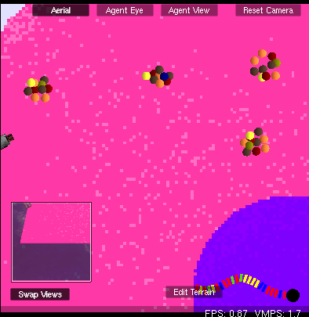
mutated sequence

- Discuss the model.
  - In what ways was the model accurate to real life?
  - In what ways was it inaccurate? Some inaccuracies included the simplified attractive and repulsive forces, the relatively short length of the amino acid chain, and the extended time over which folding occurs.

- Why is the protein folding problem so important, and why is it still unsolved?
  - Even though the proteins in the activity generally folded, the simplifications mentioned above make folding in the model far easier than folding in real life.
  - How do proteins avoid getting stuck in local minimum energy states?
    - Brainstorm ideas, such as chaperone proteins that help prevent local minima.
  - Why do we want to know how proteins fold?
    - Cure different diseases caused by protein misfolding.
    - Guess function of a protein from its sequence (useful in drug development).
    - Ability to generate real proteins from man-made sequences.
Student Worksheet:

LESSON 1: PROTEIN FOLDING

Let’s look at a simulation of the protein folding exercise on the computer. In this simulation, the amino acid sequences come from transcription of a strand of DNA and translation of the resulting mRNA. The forces in this model are simpler: similar colors repel, different colors attract.

- Setup your StarLogoTNG workspace.
  - Open the file 1-ProteinFolding.sltng.
  - Click “setup variables” in the runtime window.
  - Click “setup cell” in the runtime window. One strand of DNA, one black RNA polymerase, and one ribosome should appear in Spaceland.
  - Make sure your “temperature” slider is set to 50 to begin with.
  - Click “forever” to run the model.

- The “transcribe” button in the runtime window causes the polymerase to transcribe the DNA into RNA. The RNA moves into the cytoplasm to the ribosome and is translated into amino acid chains.

(Note: If the protein gets stuck in a corner, you may click “perturb” to move it back to the center.)

  - Create a single amino acid sequence (“transcribe”). Describe the folding behavior. Does it fold fully? Is the position stable? Does the protein move after it folds?

  - Create a few more of the same sequence (“transcribe”). Do all of the copies fold in the same way?

  - Repeat the procedure a few times with different DNA sequences (“setup variables,” “setup cell,” “transcribe”). How do these protein fold in comparison?

- Let’s mutate the DNA sequence. Click on a DNA base pair to pull up its agent monitor. Here you can change the color of each the base pair by clicking on the agent “color.” By changing the color, you are altering the DNA sequence, which may change the amino acid sequence. You can keep track of your mutations by noting the position of the base pair within the sequence in “my seq number.”
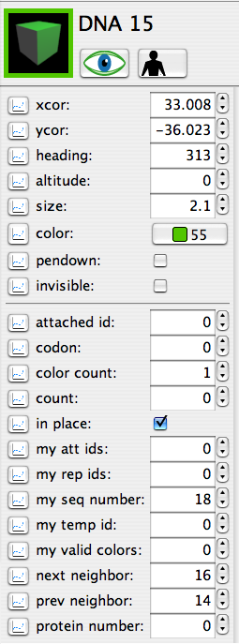

Valid DNA colors are:
Red
Green
Blue
Yellow
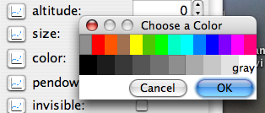

(Note:
- Clicking “setup cell” and “setup variables” will clear the board and create a new DNA sequence.
- Clicking “setup cell” without clicking “setup variables” will clear away all proteins and undo all of the mutations.
- Clicking “reset DNA colors” will only undo all of the mutations.

  - Create a non-mutated amino acid sequence and a mutated amino acid sequence. How does a small mutation in the DNA sequence affect the protein folding?

  - Insert more mutations. How do multiple mutations affect the protein folding?

- Now let’s see how temperature affects the way the protein folds. With your proteins still on the board, alter the temperature using the slider.

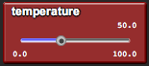

  - How does increasing the temperature affect the protein folding? At which temperatures does this effect begin to appear?

  - How does decreasing the temperature affect the protein folding? At which temperatures does this effect begin to appear?

  - What other environmental factors can affect how a protein folds?
LESSON 2: PROTEIN FUNCTION

Goals:
The goal of this lesson is for students to feel comfortable with the idea that small changes in DNA can lead to large differences.in phenotype. Double chromosomes highlight the idea of built-in redundancy to protect the cell against harmful cases of such small changes. Through the project, students can observe a simplified cell system to get a sense of how processes that they learn about (such as transcription and translation) occur continuously and concurrently within the cell. The replacement of amino acid chains with character-shaped proteins aims to bridge the gap in a student’s understanding of protein shape and protein function.

Biology Concepts:
- Protein shape dictates protein function
- Enzymes
- Diploidy
- Redundancy

Materials:
- Starter code: 2-ProteinFunction.sltng
- Blackboard/whiteboard/large paper for brainstorming

About the Model:
For more about the Basic Cell Setup, see Appendix A.
For more about “birth” procedure variables, see Appendix B.
For more about attachments and chains, see Appendix C.
The scale of this project focuses on the cell nucleus and cytoplasm.

SETUP:
“Setup Variables” clears the board, then initializes the variables and the hidden terrain agent. The terrain agent sets the “DNA sequence” as a list of 10 random DNA base colors, then hatches all of the necessary cell components when the “Setup Cell” button is clicked. The cell is initialized with two strands of DNA, five RNA polymerase, and ten assorted membrane-bound and free ribosomes. Individual agents set up their own agent variables using “birth” procedures. In particular, the DNA uses the “DNA sequence” to create a chain of base pairs matching the sequence.

FOREVER:
Terrain procedures:
- The terrain agent produces cell weeds at an average rate of once every 10 rounds, up to 75 weeds (after this the scene becomes a bit unwieldy).
Polymerase procedures:
- The polymerase wanders around the nucleus until it encounters a DNA promoter (white colored base pair), after which it sets its “attached id” to be the promoter id and uses it to follow along the strand and transcribe a strand of RNA.
- When the polymerase is attached, it chooses a ribosome as “my ribosome,” which is inherited by the RNA it produces and dictates which ribosome the RNA follows after creation.
RNA procedures:
- The RNA moves as a chain towards the ribosome set in “my ribosome.”
Ribosome procedures:
- Upon collision with the RNA, the ribosome sets its “attached id” to be the id of the first RNA base pair and uses it to follow along the strand.
- As the ribosome reads the RNA strand, it is checking the color value of each base pair to the complement of the original DNA strand. This is so that it can detect mutations.
- The default protein shape created by the ribosome is Mario. If the 4th base pair is wrong, then the ribosome creates Luigi. If the 7th base pair is wrong, then the ribosome creates Wario. Wario overrides Luigi, so simultaneous 4th and 7th base pair errors result in Wario. All other mutations are considered silent.
- After checking the RNA sequence, the ribosome hatches a protein of the given protein shape, and then it kills all of the RNA agents in the sequence.
Protein procedures:
- The protein moves around the cell and kills weeds upon impact. Mario kills every weed he encounters, Luigi kills one in every twenty-five weeds he encounters, and Wario kills no weeds he encounters.

RESET DNA COLORS:
This is the same as in Lesson 1.

GRAPH:
The graph shows the current weed population, along with a line marking a “healthy weed count” of approximately 50.

Possible Modifications:
You may choose to have the proteins performing various other tasks with various degrees of success. For instance, you may choose to have a protein that plants weeds instead of kills them, or maybe the Wario mutant plants weeds in a malicious attempt to foil Mario. DNA, RNA, polymerase, and ribosome procedures should remain the same.

In order to change the behaviors of the proteins, you may modify the “Move (Protein)” procedure and the protein-related “Collision” blocks:
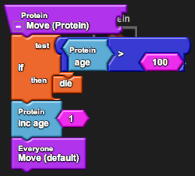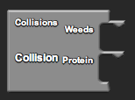

You may also choose to introduce new breeds for the proteins to interact with. The new breeds should have “<breed> Birth” procedures, and they can be setup by adding a “hatch” procedure similar to those of polymerase, ribosome, and DNA in the “Setup Cell” block by the terrain agent:

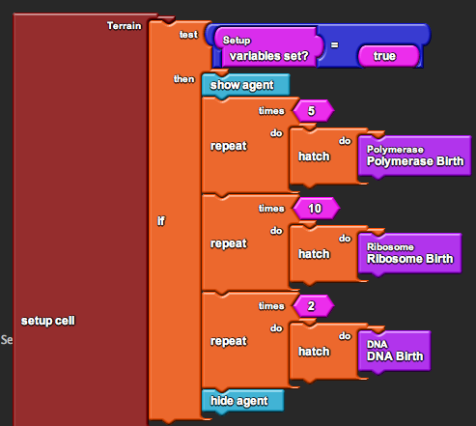
Suggested Lesson Guide:

Part 1: Discussion

- Review concepts from Lesson 1 that are relevant to this lesson.
  - A protein’s sequence uniquely determines the protein’s shape.
  - Mutations affect the DNA sequence, which may then affect the amino acid sequence, which may then affect the protein shape.

- What is so important about a protein’s shape?
  - Highlight the idea that protein shape determines protein function.
  - Note that proteins have many different functions within a cell. In this lesson we will focus on proteins as enzymes.

- What happens if there is a mutation in the gene sequence?
  - Mutations affect the protein shape, which may then affect the protein function.

Part 2: Activity

- Introduce driver/navigator roles (should you choose to use them).
  - Assign pairs.
  - Get the students on the computers and open the file.

- Demo the model first to show the ideal behavior and how to use it.
  - We have a Mario enzyme that is responsible for cleaning up weeds in the cell. However, there are two known mutations in the Mario enzyme that causes Mario to turn into either Luigi or Wario. (The Luigi mutant tries to do what Mario does, but not quite as well, and the Wario mutant refuses to do any cleaning at all. Let the students figure this out on their own.)
    - Use this opportunity to point out the parallel between proteins functioning within a cell and organisms functioning within an ecosystem, as seen in the Biology Curriculum I.
- It is the students’ job to mutate the DNA and observe the changes that each mutation causes in the weed population.

- Begin worksheet activity.
  - Students may choose to mutate the DNA randomly until they discover the known Luigi and Wario mutations. However, after they discover these, teachers should encourage students to observe the enzyme and weed populations with each mutation over enough time such that the populations stabilize. Remember that the speed of the program can be adjusted in the Runtime Window.
  - Students may also notice how slight changes in DNA and ribosome placement can create an effect on the efficiency of their cell.
    - Use this opportunity to discuss the role that randomness plays at the molecular level, as paralleled in the Biology Curriculum I.

Part 3: Debrief

- Ask students to share which mutations were crucial to shape changes in the protein.

- Discuss what happened to the weed population after each mutation was introduced.
  - Did it help that there were two strands of DNA?
  - Discuss the idea of diploidy and the redundancy this can often provide. Depending on if you have already covered mitosis and meiosis, you may choose to refer back to how two strands can inherit different alleles.

- Discuss the model.
  - In what ways was the model accurate to real life?
  - In what ways was it inaccurate? One inaccuracy was that the DNA was single stranded and contained only one gene. Another was that base pairs and amino acids are generated out of nowhere, when in reality they are taken from existing molecules in the cell. These molecules come from the degradation of RNA and proteins, such as the polymerase and ribosomes, which never die in this model.
Student Worksheet:

LESSON 2: PROTEIN FUNCTION

Your cell produces a certain Mario enzyme that gets rid of weeds in the cell. However, there are two known mutations of the enzyme that inhibit its ability to weed. In this activity, you will track down the Luigi and Wario mutants and describe their behaviors.

- Setup your StarLogoTNG workspace.
  - Open the file 2-ProteinFunction.sltng.
  - Click “setup variables” in the runtime window.
  - Click “setup cell” in the runtime window. Two strands of DNA, five black RNA polymerase, and ten ribosomes should appear in Spaceland.

- Click “forever” to run the model.
  - Describe the behavior of the Mario enzyme.

  - Click “setup cell” to clear the board and recreate all of the agents. Do you notice any changes in Spaceland? Run the model again. Did these changes affect Mario’s behavior at all?

- Click on a DNA base pair to pull up its agent monitor. Here you can change the color of each the base pair by clicking on the agent color. You may use the “reset DNA colors” button to set the colors back to the default DNA sequence colors.

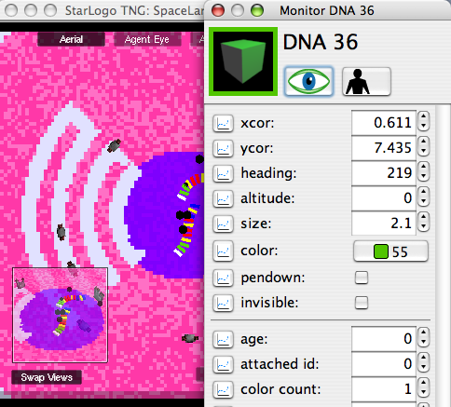

  - “Mutate” the individual base pairs by changing their colors. Click “forever” to run the model again. Which mutation causes the protein to take on the shape of Luigi? Which mutation causes the protein to take on the shape of Wario? Which mutation prevents the DNA from ever being transcribed?

  - Describe the behaviors of the Luigi and Wario mutants.

- Let’s look at the idea of diploidy.
  - When testing the mutations, did you mutate a single strand of DNA, or did you mutate both? What happens when the two strands have different sequences and produce different versions of the protein?

  - Set up the two strands to have different alleles and observe the graph of the weed population. What is necessary for the cell to maintain a healthy weed count?

  - What are some pros and cons to having two copies of the same gene?
LESSON 3: PROTEIN NETWORKS

Goals:
The goal of this project is for students to understand proteins as members of a community, just as organisms are within an ecosystem. With the support of graphs, students should be able to draw parallels between the two regarding subjects like limited resources and system niches. Most importantly, students should understand the idea of feedback as a control mechanism, particularly in achieving balance within a cell.

Biology Concepts:
- Protein niches
- Protein interactions
- Protein degradation
- Transcriptional control
- Feedback systems
- Saturation

Materials:
- Starter code: 3-ProteinNetworks.sltng
- Blackboard/whiteboard/large paper for brainstorming

About the Model:
For more about the Basic Cell Setup, see Appendix A.
For more about “birth” procedure variables, see Appendix B.
For more about attachments and chains, see Appendix C.
The scale of this project focuses on the cell nucleus, cytoplasm, and extracellular space.

SETUP:
“Setup Variables” clears the board, then initializes the variables and the hidden terrain agent. The terrain agent sets the “DNA sequence” as a list of 10 random DNA base colors, then hatches all of the necessary cell components when the “Setup Cell” button is clicked. The cell is initialized with two strands of DNA, five RNA polymerase, five membrane-bound ribosomes in the rough ER, and five each of receptor and messenger proteins. Individual agents set up their own agent variables using “birth” procedures. In particular, the DNA uses the “DNA sequence” to create a chain of base pairs matching the sequence colors.

FOREVER:
The RNA and polymerase procedures are the same as those in Lesson 2.
Ribosome procedures:
- The ribosome procedure is the same as in Lesson 2, except that the ribosome no longer checks its protein shape when hatching the enzyme. Mutation is not the focus of this exercise, though the functionality is still there and can be easily reinstalled by asking the ribosome to check this protein shape.

Enzyme procedures:
- The enzyme moves out of the cell and “eats donuts” upon impact. The enzyme starts off being able to travel within the cell as it makes its way to the extracellular space, but when it exits, it sets its “my valid colors” list to include only the extracell-color.
- The enzyme ages with each round and dies after 200 rounds.
Donut procedures:
- The donut wanders around the extracellular space until it collides with an enzyme and gets eaten.
Receptor procedures:
- The receptor begins with no attached messenger. When it collides with a messenger, if neither is attached to another protein, each sets its “attached id” to the collidee.
- If the receptor is attached when it encounters a donut, it releases a message by detaching and setting “has message?” of the messenger to be “true.”
Messenger procedures:
- The messenger begins with no attached receptor. When it collides with a receptor, if neither is attached to another protein, each sets its “attached id” to the collidee.
- If the messenger is attached, it follows the receptor around the inside of the cellular membrane. If is it not attached, the messenger wanders around the cytoplasm.
- When the messenger is wandering the cytoplasm, it can either have a message or not. If “has message?” is true, then the messenger wanders until it encounters a promoter (black/white colored base pair) and turns it on (sets the color to white). After this, it sets “has message?” to be “false.” If “has message?” is false, then the messenger wanders until it encounters a receptor and then tries to attach.
DNA procedures:
- When a receptor turns on a promoter, it also sets the age of the promoter to be 100. Then, with each round the age is decreased, and when it hits zero the promoter is turned off (sets the color to black).

FEED:
The slider “food amount” dictates how many donuts will be injected into the system when “Feed” is clicked. Any donuts that do not appear in the extracellular space die immediately, so this number may vary a little.

GRAPH:
The graph shows the current enzyme population and the current donut population.

Possible Modifications:
You may choose to include mutation in this activity as well (beware of cluttering the lesson, though). In order to do this, just edit the “Get Protein Shape” procedure in the ribosome with appropriate shapes, set the shape to “my prot shape” in the “Enzyme Birth” procedure, and change the behavior in the “Move (Enzyme)” procedure and the enzyme-related “Collision” blocks. Refer to Lesson 2 for a template.
Suggested Lesson Guide:

Part 1: Discussion

- Review the concepts from Lesson 2 that are relevant to this lesson.
  - A protein’s shape determines the protein’s function.
  - Proteins carry out various tasks within the cell. Each has its own niche in the cell as organisms have their own niches in an ecosystem.

- Let’s expand on this idea of a protein ecosystem.
  - What were the responsibilities of the carrots, bunnies, wolves, and hunters in the ecosystem unit?
  - What are possible responsibilities of proteins in and outside of a cell?
    - Brainstorm a list on the board.

- Proteins often function as part of large network communities. What is one of the most important aspects of being in a community? Communication!
  - Since proteins cannot speak to each other, how do they communicate?
    - Brainstorm a list on the board.
  - Recall from Lesson 1 that a protein’s shape is determined by the various chemical forces that affect it. Many proteins undergo conformational changes after interacting with other molecules.
    - Changes can happen if the protein binds to the molecule.
    - Changes can also happen if the molecule alters the protein somehow, such as through phosphorylation or methylation.
  - In the activity, we are going to focus on the idea of feedback.

Part 2: Activity

- Introduce driver/navigator roles (should you choose to use them).
  - Assign pairs.
  - Get the students on the computers and open the file.

- Demo the model first to show the ideal behavior and how to use it.
  - We have a Homer enzyme that is responsible for cleaning up donuts outside of the cell. However, Homer only comes out of the cell when he knows donuts are present, so he sets Marge up in the cell membrane to scout for donuts. However, Marge cannot leave her post in the cell membrane, so she sends a car home with a message every time she encounters a donut.
  - Select a small number of donuts with the slider and inject them into the cell.
  - Note the similarities and differences in this lesson to Lesson 2.
    - The polymerase transcribes the DNA and the ribosome translates the RNA as before, except that the DNA transcription is regulated by the presence of donuts outside of the cell.
    - Homer is an enzyme like Mario, except that his substrate is outside the cell. Hence, Homer is produced by membrane-bound ribosomes, and he is bundled in a white vesicle until he exits the cell.
    - Like Marge and the car, the proteins in this lesson are generally restricted to certain parts of the cell, relying on each other for relaying information.
    - We are going to focus on feedback and not mutation in this lesson.

- Begin worksheet activity.
  - Encourage students to proceed with the feeding in a methodical way, incrementally increasing the amount of donuts that are injected.
  - Students may also notice how sometimes the cars will take a long time to find the Marge or the DNA, causing a longer delay in Homer enzyme production.
    - Use this opportunity to discuss the role that randomness plays at the molecular level, as paralleled in the Biology Curriculum I.

Part 3: Debrief

- Ask students to share their results regarding the feedback system.
  - How were the molecules able to communicate within the cell?
    - Cars that have a “message” release from Marge and turn blue. They turn back to their car colors after they’ve delivered the message to the DNA.
    - The DNA promoter used to be white in Lesson 2. Now it is black (turned off) by default and turns white (turned on) after it receives a message.
  - How did the feedback system work? Was this positive or negative feedback? What would be an example of positive feedback?
  - What happened when the donut input increased?
    - Students that methodically increased their donut input should notice that the enzymes produced in each round should also increase steadily up to a certain point. At this point, it will plateau as carrot growth did in Biology Curriculum I. Discuss the limited number of receptors and the idea of saturation.
  - Did students notice any other similarities to Biology Curriculum I?
    - The relationship between the substrate and the enzyme populations roughly mimicked a predator-prey cycle, except that the cycle began with donut injection and not naturally from “donut reproduction.”
  - The feedback in this project was based on transcriptional control. Ask students what other steps in the whole process could be used to control protein creation.

- Why is a feedback system necessary? Why not just produce the protein all the time?
  - Producing the protein at all times would be a waste of resources.
  - Producing the protein at all times might not only mean proteins where we don’t need them, but also proteins where we don’t want them.

- Protein networks within a cell can be huge. If a mutation occurs in the middle of a protein signaling chain, many things could break. So, what is the benefit to such a complex system?
  - Brainstorm a list on the board. Note that there is no definite answer to this.
  - Some ideas include more fine-tuned control over the body’s processes. There could be many different factors controlling the production of a single protein, making the amount of protein produced in any given situation more precise.

- Discuss the model.
  - In what ways was the model accurate to real life?
  - In what ways was it inaccurate? Aside from the inaccuracies from Lesson 2, the model represents only a tiny portion of everything happening within the cell. Even the increased complexity of a small protein network was extremely simple in comparison. Additionally, many details of how transcription factors work are largely overlooked in this model.
Student Worksheet:

LESSON 3: PROTEIN NETWORKS

Your cell produces a certain Homer enzyme that gets eats donuts outside of the cell. However, Homer is too lazy to come out of the cell unless he knows that donuts are around. Instead, he has Marge stationed at the cell membrane scouting for donuts. When Marge encounters donuts, she sends a car back to the nucleus with a message to produce Homer enzymes. In this activity, you will observe this feedback system for controlling Homer enzyme production.

- Setup your StarLogoTNG workspace.
  - Open the file 3-ProteinNetworks.sltng.
  - Click “setup variables” in the runtime window.
  - Click “setup cell” in the runtime window. Two strands of DNA, five black RNA polymerase, five ribosomes, five Marge receptor proteins, and five car messenger proteins should appear in Spaceland.
  - Click “forever” to run the model until all of the car messengers have attached to a Marge receptors.

- You will be injecting donuts into the extracellular space as substrates for the Homer enzyme.
  - In the Runtime Window, you will see a slider to control the amount of food input. Slide the slider to change this value, then click “Feed” to create the donuts.

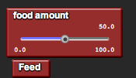

Try inputting different amounts of donuts and observe the relative populations of Homer enzymes and donuts in the graph over time. Make sure that you wait until all Homer enzymes and donuts disappear and all cars are attached to Marge receptors before each injection.

  - Describe how this feedback system works.

  - How does the population of enzymes behave as donuts are injected?

  - How does the population increase as the donut amount increases?

- We have made the analogy of protein networks as micro-ecosystems.
  - In what ways do the proteins in this cell act as members of an ecosystem?

  - How do the molecules in this cell communicate?
LESSON 4: CELLS

Goals:
The goal of the last project is to tie cellular processes to phenotypes detectable by humans. Students should understand how the location of a mutation within a gene and the location of a mutation within an organism’s body combine to determine the effect that the mutation has. Students can manipulate code describing the effect of a mutation to inform them of which various cell cycle mutations are most likely to cause cancer. Then students can manipulate code describing various cancer to treatments to inform them of the pros and cons of such treatments. Finally, designing a game for their peers will give students an opportunity to showcase some of these lessons.

Biology Concepts:
- Phenotypes
- Stem cells and differentiated cells
- Mutations in cell cycle
- Tumors and cancer
- Cancer treatments

Materials:
- Starter code: 4-cells.sltng
- Blackboard/whiteboard/large paper for brainstorming

About the Model:
This model does not use the Basic Cell Setup.
For more about “birth” procedure variables, see Appendix B.
For more about attachments and chains, see Appendix C.
The scale of this project focuses on the cell in tissue and the lumen.

SETUP:
“Setup” clears the board, then creates the necessary agents. There is one terrain agent, one cell, and one “tumor eater.” The cell variables are set up using its “birth” procedure.

FOREVER:
The food procedures are the same as those in Lesson 3.
Terrain procedures:
- The terrain agent wanders around Spaceland setting the “cell to mutate” variable to ids of different cells it encounters. If a mutation occurs while a particular cell is the “cell to mutate,” then that cell is mutated. This helps to spread the mutations out more randomly around the board.
- The terrain agent also keeps score. The tumor starts out with “tumor growing?” false. If the tumor size grows to larger than “beginning tumor size” number of cells, then “tumor growing?” is set to “true.” If the tumor is completely eliminated, then “tumor growing?” is set back to “false.” If “tumor growing?” is true, then the terrain agent increases the score with every round.

Enzyme procedures:
- The enzyme moves around the extracellular space and “eats donuts” upon impact.
- The enzyme ages with each round and dies after 50 rounds.
Cell procedures:
- The cell hatches enzymes if it encounters a donut and “damage enzyme gene?” is false. Because collisions in StarLogoTNG are sensitive, a cell and enzyme may detect a collision for several rounds in one encounter. Therefore, there is a “message delay” for 10 rounds to prevent the cell from creating excess enzymes.
- The cell ages with each round and dies after “death age” number of rounds. 5 rounds prior to death, the cell begins to darken in color to aid in visualization of the process. A cell with “damage enzyme gene?” usually has a higher death age.
- In the first half of the cell’s lifespan, the cell also moves around the randomly. A cell with “damage enzyme gene?” continues to move through its life.
- If the density of cells within radius 3 is less than “density,” the cell will replicate. A cell with “damage enzyme gene?” usually has a higher tolerable “density.”
- A healthy cell moves away upon collision with a “damage enzyme gene?” cell.
Tumor eater procedures:
- The following procedures only occur after the game has started (score > 0).
  - Chemo (keyboard spacebar): Every third cell dies.
  - Heat Blast (keyboard x): Every cell within radius 10 of the tumor eater dies.
  - Excision (keyboard arrows keys): The tumor eater moves, and any cells it collides with die.

FEED:
The slider “food amount” dictates how many donuts will be injected into the system when “Feed” is clicked. Any donuts that do not appear in the extracellular space die immediately, so this number may vary a little.

MUTATE ENZYME GENE:
The slider “mutagen strength” dictates the likelihood that the “cell to mutate” (chosen by the terrain agent) will be mutated. If a cell is mutated, its “damage enzyme gene?” is set to “true” and its color is set to purple.

MUTATE REPLICATION GENE:
The slider “mutagen strength” dictates the likelihood that the “cell to mutate” (chosen by the terrain agent) will be mutated. If a cell is mutated, its “damage replication gene?” is set to “true” and its color is set to white. In addition, some aspect of its livelihood is altered. The default case is doubling the death age.

RESET SCORE:
The score is set to 0, “tumor growing?” is set to “false,” and “beginning tumor size” is set to 25.

GRAPH:
The graph shows the populations of healthy cells, defective enzyme cells, tumor cells, enzyme, and food.
Suggested Lesson Guide:

Part 1: Discussion

- Review the concepts from Lessons 1, 2, and 3 that are relevant to this lesson.
  - Mutations in DNA can cause a protein to fold differently, changing its shape.
  - Changes in a protein’s shape affect its function.

- Introduce the day’s activity.
  - We are going to zoom out and observe how mutations can affect not just a single cell but also groups of cells in tissue. The danger of a mutation can be great or small, depending on whether or not the mutation can be easily propagated.
  - The spread of the effect depends largely on the type of cell that is mutated.
    - Discuss the differences between stem cells and differentiated cells.
  - The spread of the effect also depends on the type of gene that is mutated.
    - Discuss the idea of cell cycle mutations, esp. in relation to cancer.

Part 2: Activity

- Introduce driver/navigator roles (should you choose to use them).
  - Assign pairs.
  - Get the students on the computers and open the file.

- Demo the model first to give a brief overview of what is going on.
  - The single cell represents a stem cell from which all of the other cells in the tissue are derived. The accelerated cloning at the start represents formation of the tissue.
    - Notice that the growth curve of the cells also plateaus to hit carrying capacity, as the carrots did in Biology Curriculum 1.
  - Mutations can occur prior to the replication, or they can occur after the tissue is more or less formed. A mutation in the enzyme gene affects the ability of the protein produced to break down substrate. A mutation in the replication gene affects many factors in the cell cycle, which determine how long the cell can survive and how quickly it can replicate.
  - Pink cells are healthy, purple cells cannot break down substrate, and white cells are tumor cells.

- Begin worksheet activity.
  - Students may notice that not all tumor cells end up forming tumors. Note that a tumor cell only becomes a tumor when it is given the opportunity to replicate uncontrollably. It may be the case that the cell has no space to replicate and eventually dies off.
    - Use this opportunity to discuss the role that randomness plays at the molecular level, as paralleled in the Biology Curriculum I.
    - Highlight that this is why cancer usually only arises in areas with rapidly dividing cellss.
  - Trying to kill the tumor by guiding the “tumor eater” agent may be more intuitive when done under the “agent view” camera because the keyboard arrows lend themselves to first person gaming.

Part 3: Debrief

- Ask students to share their results on the various mutations.
  - How does a mutation in the enzyme gene affect substrate breakdown when introduced at the single-cell stage? What about at the multi-cell tissue stage?
    - This emphasizes the difference of an allele that is inherited and therefore present in all of the cells that arise from the fertilized egg, versus an allele that is created randomly in a single differentiated cell.
  - How does a mutation in the replication gene affect replication of a tumor cell? Which factors of the cell cycle affected the tumor growth the most?

- Discuss the pros and cons of the various tumor treatments: surgical extraction, chemotherapy, and heat blasting via targeted nanoparticles.

- Discuss the model.
  - In what ways was the model accurate to real life?
  - In what ways was it inaccurate?

Part 4: Game

- Give students time to redesign the terrain and create a new play level.
  - Encourage the students to use what they have observed regarding how the tumor cells replicate to mark a terrain that will foster tumor growth.
  - Students are also allowed to set the tumor cell parameters to foster tumor growth.
  - Increasing the “beginning tumor size” forces the player to wait longer until the tumor is larger before treatment begins, making it more difficult to get rid of.

- Ask each group to switch with another group and play each other’s games.

- Discuss which design made the most difficult tumor to beat. Discuss which design made the most fun tumor to beat.
Student Worksheet:

LESSON 4: CELLS

Part 1:

So far we have seen the way in which mutations affect the DNA sequence, the RNA sequence, the amino acid sequence, the protein shape, and the protein function within a cell. Now we will look at how a mutation in one cell of an individual affects the overall well-being of that individual.

- Setup your StarLogoTNG workspace.
  - Open the file 4-Cells.sltng.
  - Click “setup” in the runtime window. A single cell will be created within the pink portion of the terrain. This cell could be a zygote, or it could be just a stem cell, but it will be responsible for creating all of the cells within your tissue.
  - Click “forever” to run the model until the entire tissue is generated. Describe the graph of the cell population.

  - Use the slider to select the “food amount” and click “Feed.” This should have the same behavior as in Lesson 3.

- Let’s mutate a cell.
  - Select a “mutagen strength” using the slider in the Runtime Window. Mutagen strength of 100 will cause a cell to be mutated each time “mutate enzyme gene” is pressed. Mutagen strength of 0 will cause no cells to ever be mutated. The mutated cell will show up purple.

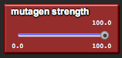

With the tissue fully generated, click “mutate enzyme gene.”

  - Click “Feed.” How does the mutation affect the overall ability of the tissue to breakdown substrate?

  - Click “setup” to clear the board. With only a single cell, click “mutate enzyme gene,” and then click “forever” to run the model under the entire tissue is generated.

  - Click “Feed.” How does the mutation affect the overall ability of the tissue to breakdown substrate now?

- Cell-cycle mutations are unique mutations that can cause tumors and cancer.
  - List some aspects of the cell cycle that, when disrupted, could cause a cell to grow uncontrollably.

  - Click “setup” to clear the board, then click “forever” to run the model until the entire tissue is generated. This time, click “mutate replication gene.”

  - Observe the graph of the cell population. Is your tumor growing? If so, describe its growth. If not, try mutating another cell. How is the tumor growth affecting healthy cell growth?

  - In this particular model, the cell-cycle mutation allows the cell to grow in less space (higher density). Other mutations could cause the cell to generate more offspring with each replication, or live longer.

In the StarLogoTNG canvas, under the Runtime Window, you will find the block for “mutate replication gene.” Swap the “set density” block for either “set offspring” or “set death age.” Repeat the simulation.

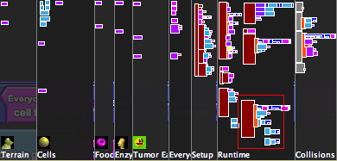
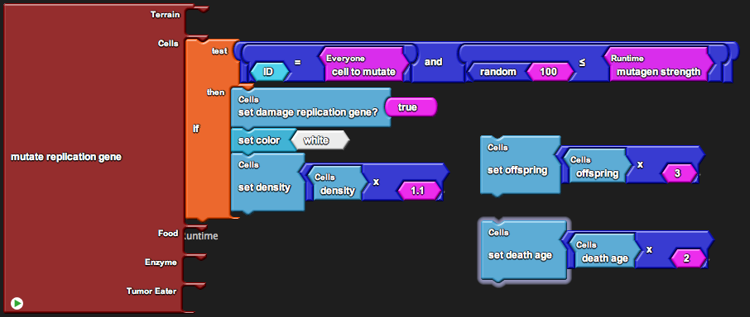

Is one mutation more effective than another? What if you combine them?

Part 2:

If you notice, once the tumor grows to a size of at least 25 cells, the “Score” value at the bottom right corner of the Spaceland window begins to increase. Let’s play a game!

Notice that there is a small yellow Pacman in the bottom left corner of Spaceland. We’ll call him the “tumor eater,” and he represents various treatments for getting rid of tumors.

- When the score begins to increase, that means that the game has started, and you can move the tumor eater with keyboard keys.

- There are three types of treatments in this case:

  - Excision (arrow keys): Any cell the tumor eater encounters is destroyed.

  - Heat blasting (x-key): All cells within a certain radius of the tumor eater is destroyed.

  - Chemotherapy (space-bar): Every three cells dies.

- The goal is to get rid of the tumor. The faster you do this, the lower your score.

Part 3:

Now you will design a game level for your classmates. Use what you know about tumor growth to adjust the difficulty of the level.

- Edit the terrain. Cells will only grow in patches that are colored (pink + 2).

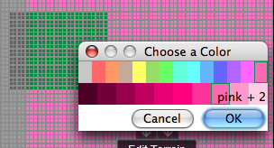

Click on the “Levels” tab in the Runtime Window and create a new level. Save your terrain in the new level.

- Make sure that your initial cell is located in a valid pink patch. If you are in “Edit Terrain” mode, you can mouse over the terrain and get the x and y coordinates of any point.

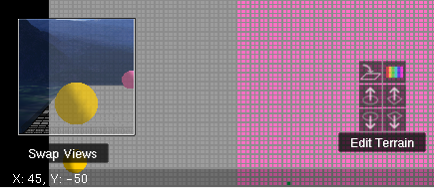

Once you have decided on the location, program it into the “setup” block.

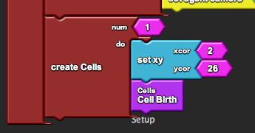

If you have more than one pink section, create a cell in each by duplicating this block.

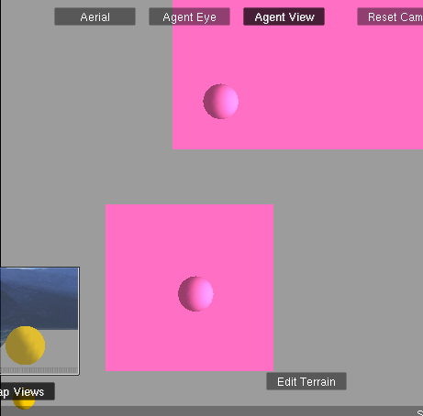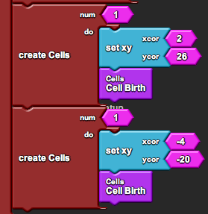

- Recall how we mixed and matched the “set density,” “set offspring,” and “set death age” blocks in the “mutate replication gene” procedure. You may choose to do this again to increase or decrease the speed in which your tumor grows.

- Finally, a larger tumor is more difficult to defeat. To change the tumor size at which the game begins, simply change the the “beginning tumor size” variable in the “setup” block.

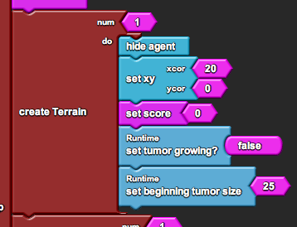

- Now switch with another group and play each other’s games!

APPENDIX A: BasicCellSetup.sltng

BasicCellSetup.sltng contains starter code for drawing a cell in StarLogo TNG and defining agent movement within the cell.

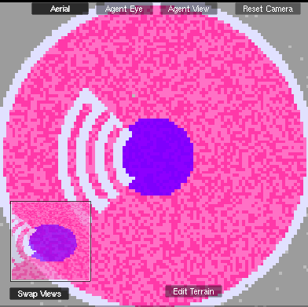

HOW TO USE:

“Setup Variables” sets the variables defining the cell center coordinates (cell-center-x, cell-center-y), the various section colors (nucleus-color, cytoplasm-color, membrane-color, lumen-color), and the various section sizes (nucleus-radius, cell-radius, membrane-thickness). Simple customization of sizes and colors can be done by changing these variable values in the “setup variables” block.

A “terrain” agent is created that can redraw the cell with these new variable values, but because the terrain can be saved with the project file and does not need to be recreated each time, we hide the reset block from the students and leave the actual terrain resetting for the teacher during the creation of the file. The terrain agent is also responsible for various maintenance tasks within the cell, acting as an “Observer” character. To “Reset Terrain,” simply double-click on the block at the top of the setup section of the canvas:

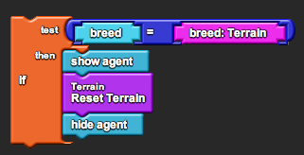
The code contains built-in procedures for restricting agents to certain sections of the cell. To tell agents which sections are valid, the code must set the agent’s “my valid colors” variable upon creation. Then, the procedure “Forward-Limited” works the same way as “forward,” except that the agent can only move if space it is moving to is of a valid color. The procedure utilizes the helper procedure “In-Place?” which simply parses through an agent’s “my valid colors” list and checks if the current patch color is part of the list. The following example of setting the “my valid colors” variable sets an agent up to move only within the nucleus and cytoplasm of the cell:

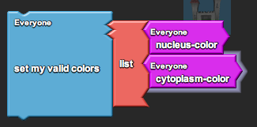

HOW TO CUSTOMIZE:

Two easy ways to customize the code are to create new variables or to change the way the terrain is setup.

To create new variables, you must simply declare a new variable and set its value in the “setup variables” block:

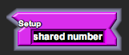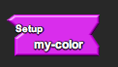

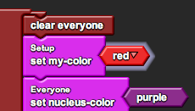

To change the way the terrain is setup, you must edit the procedure “Reset Terrain.” Currently, the procedure runs through a reset of each respective part of the cell (the yields in between are just so the agent passes an update after each step). You may choose to edit these sub-procedures, or you may choose to create new ones.

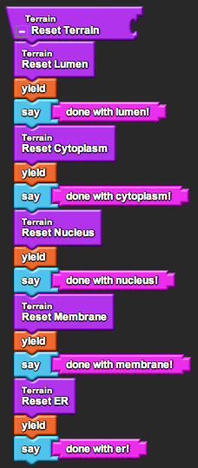

The procedures “Stamp Random Circle,” “Stamp Random Circle Boundary,” and “Stamp Square” may be of use. “Stamp Random Circle” stamps a single circle, as in the nucleus. “Stamp Random Circle Boundary” stamps a circle within a given min and max degree, as in the edges of the endoplasmic reticulum. “Stamp Square” stamps a single square, as in the lumen filling up the rest of Spaceland.
APPENDIX B: “Birth” procedures

The idea of a standard “birth” procedure helps to organize all of an agent’s variables in one place, making sure that they are all set correctly when the agent is created. These procedures may also include sub-procedures that the agent must do upon creation.

The following are variables that have been used in the cell units. Any variables that are not built in to StarLogoTNG are italicized.

Essential variables:
- breed
- my valid colors
- size

Typical variables:
- color
- shape
- xy
- heading

Unique variables:
- shape width (DNA)
- age (protein)
- attached id (polymerase, ribosome, receptor, messenger)
- my RNA seq id (ribosome)
- my prot shape (ribosome)
- has message? (messenger)
APPENDIX C: Attachments and Chains

Links are used extensively throughout the cellular biology units as a way to represent various forms of chemical bonding. To represent a link, agents store agent ID numbers of other agents they are linked to, with -1 being the equivalent of a null ID (e.g. no link). The links come in two forms: attachments and chains.

Agents attach to one another by setting their “attached id” values. By having an “attached id” value, an agent can keep tabs on its attached agent, accessing its variables through “<variable> of attached id.” An example of this is when the messenger and receptor proteins attach to one another upon collision and release when the messenger must send a message to the nucleus. The release is created when both agents set their “attached id” values to -1.

Agents within a chain store two ID numbers: “next neighbor” and “prev neighbor.” The former is the ID of the agent to its front, and the latter is the ID of the agent to its back. This allows agents within a chain to follow one another and keep track of where the chain is. It also allows other agents to interact with the chain and move along it, such as polymerases reading DNA or ribosomes reading RNA. The other agents use “attached id” to recognize a single location in the chain, and then they can use “next neighbor of attached id” or “prev neighbor of attached id” to move forward or backward in the chain. A “next neighbor” or “prev neighbor” value of -1 indicates the ends of the chain.

